

Practices for Secure Software Report

Table of Contents
Document Revision History 3
Client 3
Instructions 3
Developer 4
1. Algorithm Cipher 4
2. Certificate Generation 4
3. Deploy Cipher 4
4. Secure Communications 4
5. Secondary Testing 4
6. Functional Testing 4
7. Summary 4
8. Industry Standard Best Practices 4

Document Revision History

Version | Date | Author | Comments
1.0 | 8-16-2026 | Spenser VanSteenwyk | Initial setup

Client



Instructions

Submit this completed practices for secure software report. Replace the bracketed text with the relevant information. You must document your process for writing secure communications and refactoring code that complies with software security testing protocols.

- Respond to the steps outlined below and include your findings.
- Respond using your own words. You may also choose to include images or supporting materials. If you include them, make certain to insert them in all the relevant locations in the document.
- Refer to the Project Two Guidelines and Rubric for more detailed instructions about each section of the template.

Developer
Spenser VanSteenwyk

Algorithm Cipher

I recommend the AES-256 algorithm cipher for Artemis Financial because it provides strong protection for sensitive financial information. AES-256 uses a 256-bit key and is a symmetric encryption algorithm, meaning the same secret key is used to encrypt and decrypt data. Although AES-256 is recommended for encrypting sensitive data, the checksum implementation is used by SHA-256 through Java's MessageDigest class. SHA-256 is a cryptographic hash function rather than an encryption algorithm and is used to verify the integrity of the data.

Certificate Generation
Insert a screenshot below of the CER file.

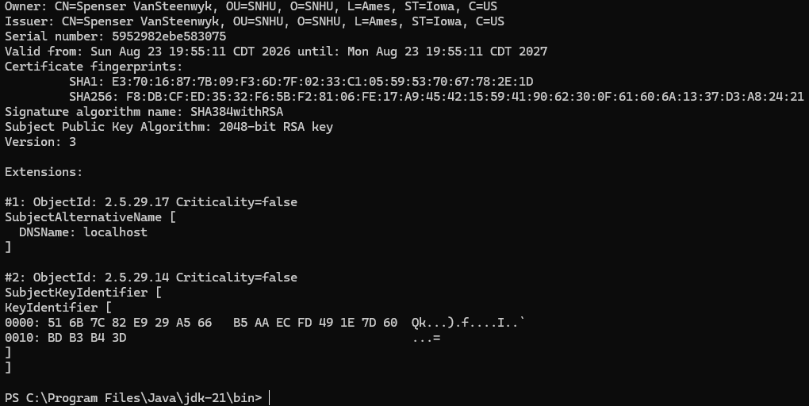

Deploy Cipher
Insert a screenshot below of the checksum verification.

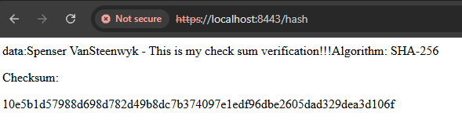

Secure Communications
Insert a screenshot below of the web browser that shows a secure webpage.

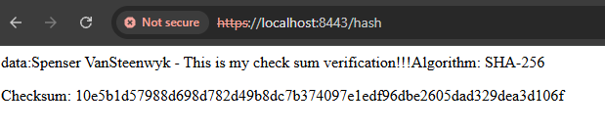

Secondary Testing
Insert screenshots below of the refactored code executed without errors and the dependency-check report.

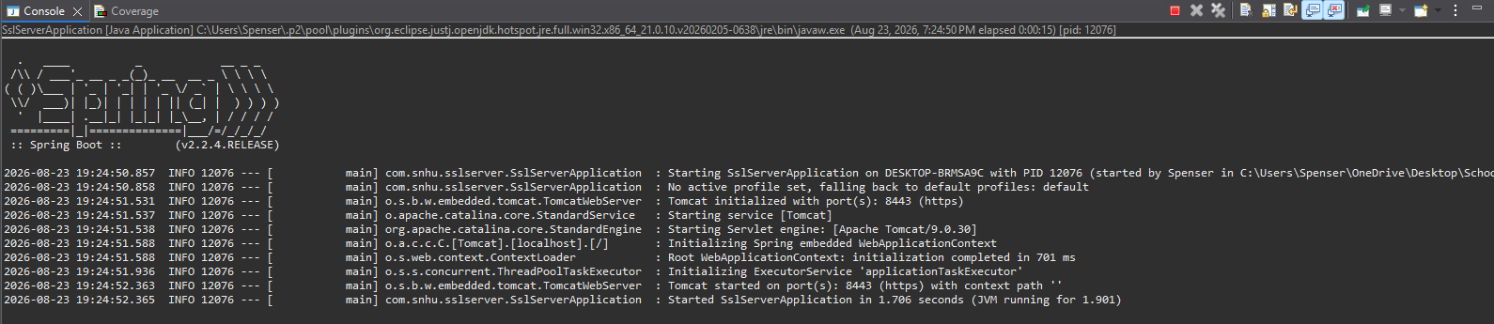
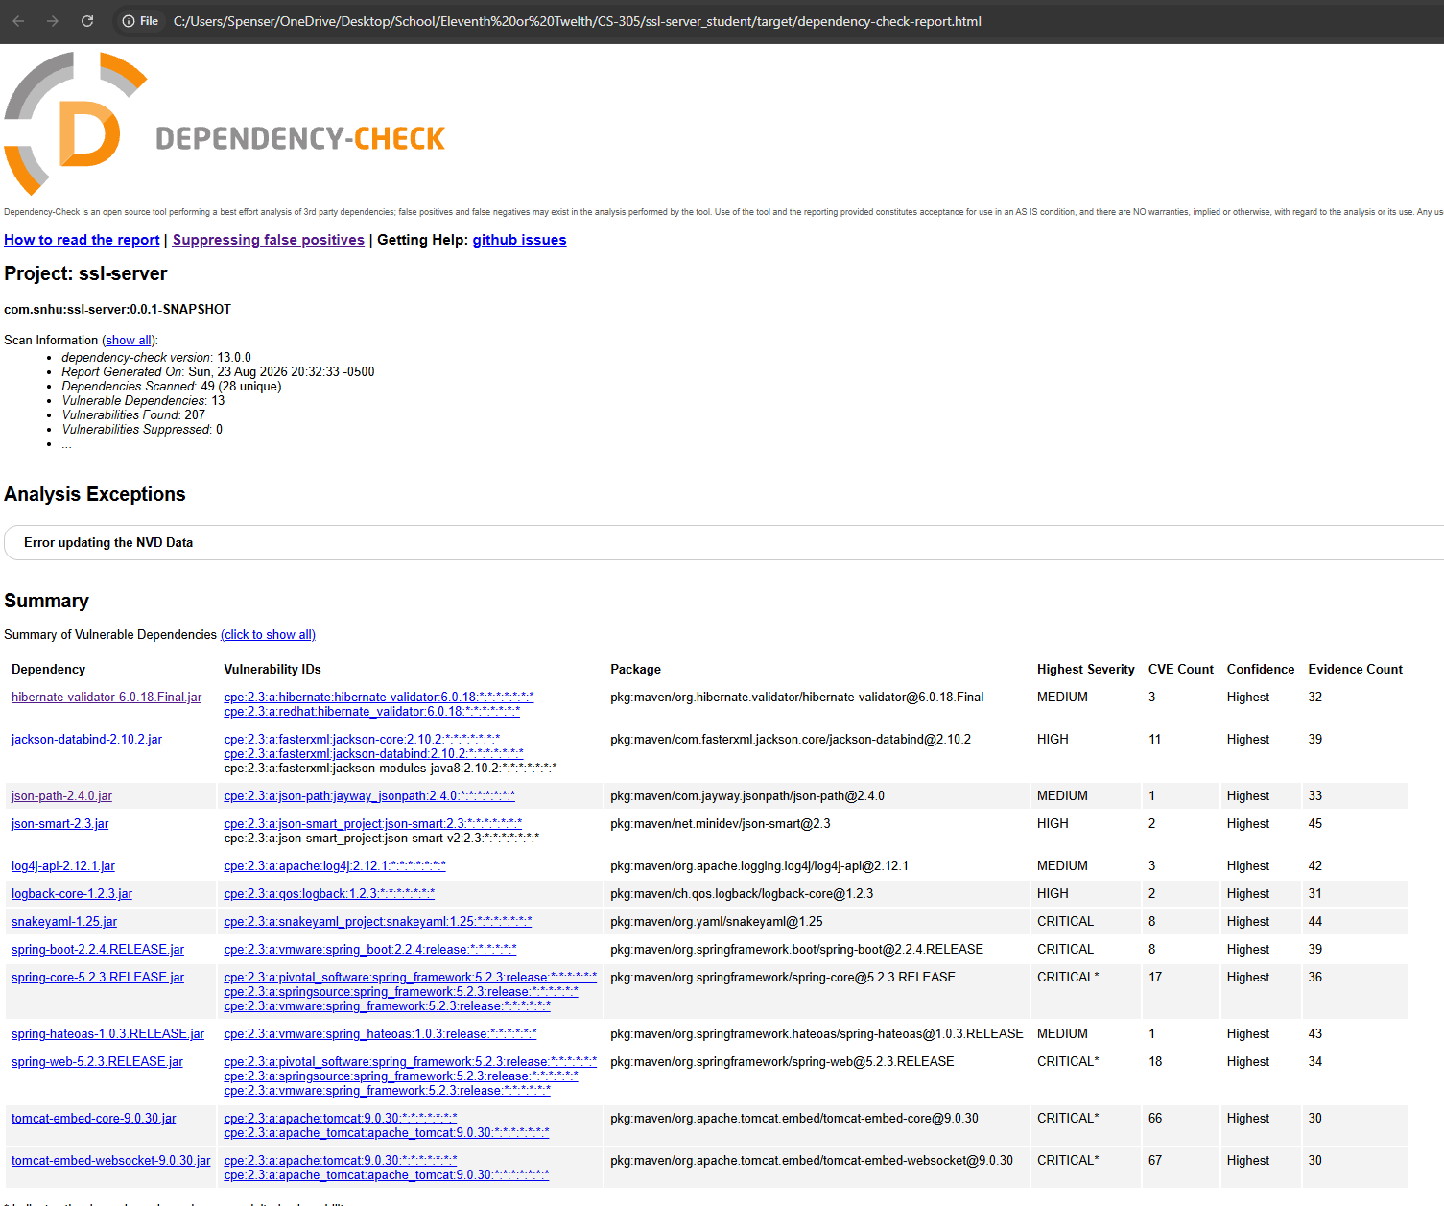

Functional Testing
Insert a screenshot below of the refactored code executed without errors.

I manually reviewed the refactored code for syntactical, logical, and security issues. I added a SHA-256 checksum using the Java MessageDigest class to verify the integrity of the data. I also updated the application properties to use HTTPS on port 8443 and configured the application to use a self-signed certificate and keystore. The certificate was updated to include my information and localhost as a Subject Alternative Name so it could be used with the localhost HTTPS connection. After making these changes, I compiled and ran the application successfully without errors.
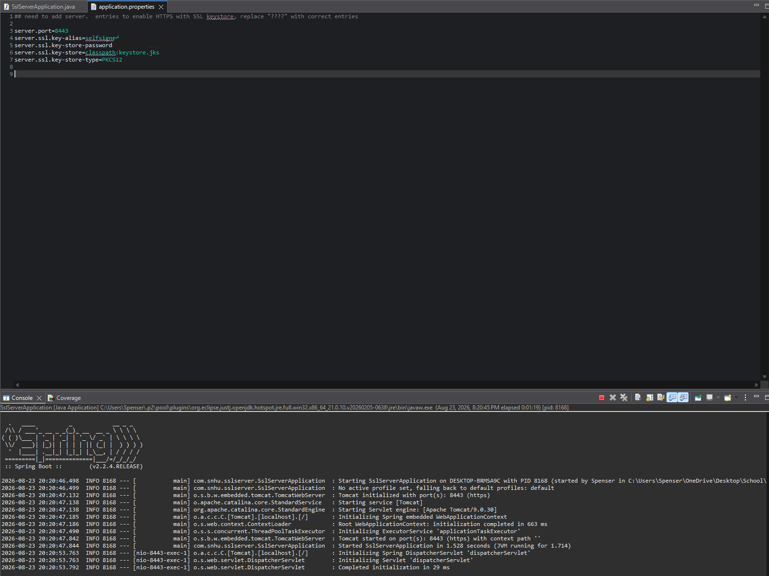
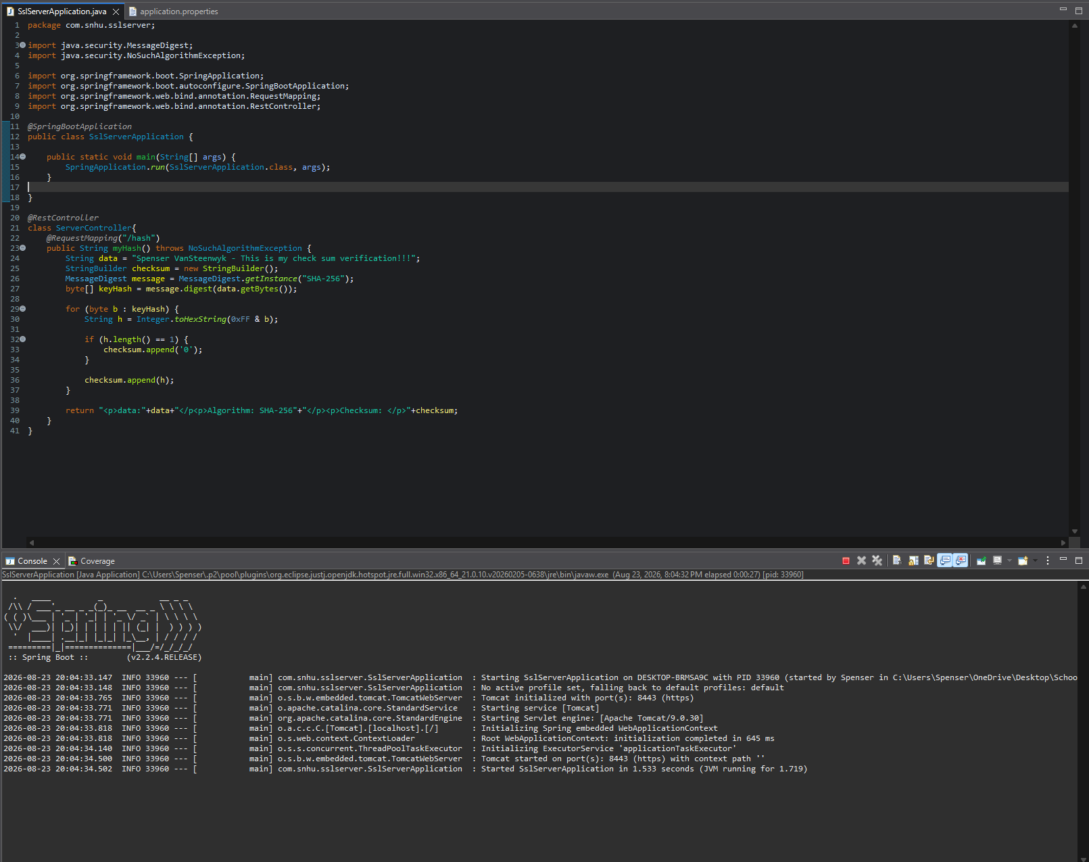

Summary

When doing the vulnerability test, I updated several areas for security by refactoring the application. I added SHA-256 checksum using the MessageDigest class to help verify the transferred data’s integrity. I also updated the application properties to use HTTPS and created a self-signed certificate. I also created a keystore to support secure communication. I then added a dependency check and manually reviewed the code for issues relating to syntactical, logical, and security. These steps helped me identify vulnerabilities and verify that the changes I made did not introduce errors into the application. I addressed different parts of the application instead of just making changes for one security measure. The SHA-256 checksum provides a way to verify data integrity, while HTTPS helps protect data during communication. The certificate and keystore support the secure HTTPS connection. Finally, static testing and manual testing were used to review the application for potential vulnerabilities and errors.

Industry Standard Best Practices

I applied industry standard secure coding practices by using established security features provided by Java and Spring Boot. For the checksum implementation, I used the Java MessageDigest class with the SHA-256 algorithm rather than implementing a custom hashing algorithm. I also configured HTTPS using a keystore and self-signed certificate to help protect communication between the application and the user. After refactoring the code, I performed static testing with Dependency-Check and manually tested the application to help maintain security of the software. Applying industry standard secure coding practices is valuable to the overall well-being of the client and its clients because it helps reduce the risk of security vulnerabilities affecting sensitive information. Since Artemis Financial handles customer financial data, protecting the confidentiality and integrity of that information is important. Using secure coding practices, testing for vulnerabilities, and reviewing changes before deployment can help identify security issues earlier in the development process. This can help protect customer trust and reduce the potential impact of security vulnerabilities.

